Findings Guide
  - PST 315: Methods of Policy Analysis and Presentation
Prof. Jack Reilly
Fall 2026
Each finding and the accompanying graph, source, and comment will have its own page in the report.
General layout of a findings page
- Finding statement
- Graph
- Source
- Comment (if needed)
- Page break
Finding statement
- Your first finding statement will go two lines below the “FINDINGS” header.
- Your finding statement should be numbered (for example, your fourth finding will start “4.”).
- Do not include an indent anywhere in the finding statement.
- Do not include (n=) at the end of your finding statement in the Findings section. This is because (n=) should be included in your graph.
  - Note: you will include (n=) following your findings in the Executive Summary.
- See class slides for how to write finding statements.
Graph
- You will copy and paste your graph below your finding statement.
- Graphs should be made in Excel.
- Follow the PST 315 Graphing Guidelines!
- Your graph should be centered on the page.
- Do not insert a screenshot of your graph.
Source
Below your graph you will type the source of your graph directly into the Word document. The source should read something along the lines of: “Data collected by John Doe and analyzed by Jane Doe for XYZ Organization, Community Link Project, November 2025.”
Comment
Some graphs will require a comment typed into Word below the source. This includes aggregated graphs, open-ended response graphs, graphs where the percentages do not add up to 100%, and graphs where you group multiple responses into one category (including “other” categories).
Page break
To insert a new page, add a page break. Do not add a section break. Use Insert -> Page Break, and begin your next finding at the start of the next page.

Example findings page
About this example
This example uses sample data. Skills Win Coaching Organization is a real Syracuse University program, but the numbers shown are invented for teaching purposes and are not actual SWCO results.
The whole page – statement, graph, source, and comment – looks like this:
- 34% of respondents said more activities would improve the site sessions.
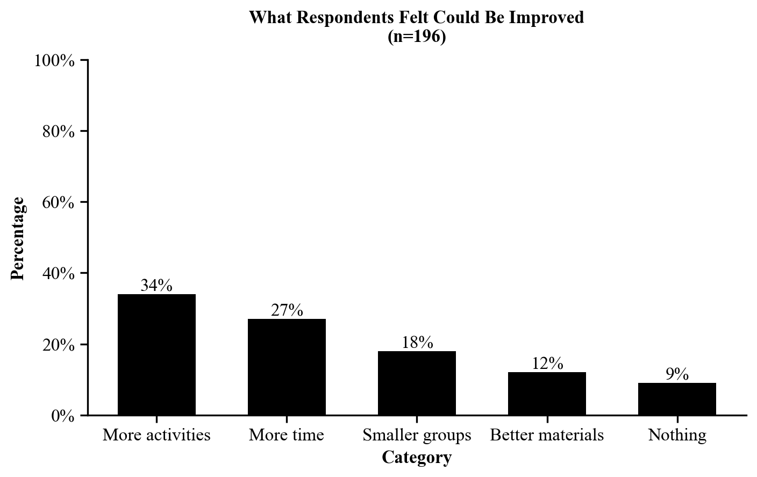
Source: Sample data collected and analyzed by Jordan Alvarez for the Skills Win Coaching Organization, Community Link Project, November 2026.
Comment: Respondents could give only one answer, so percentages total 100%. Responses that named a specific activity were grouped into “More activities.”

